STEPS TO SETTING UP BOONE CENTRAL HOT LUNCH ACCOUNT ONLINE PORTAL VIEW
- Go to Powerschool and login
- Click on the Lunch Portal
- Click Set Up Account, Read terms of service and Accept
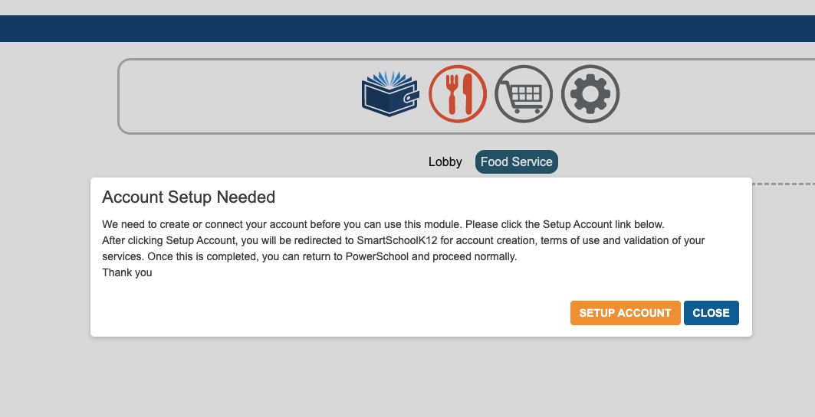
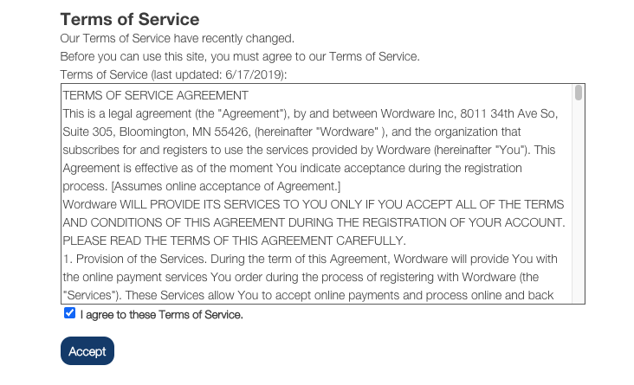
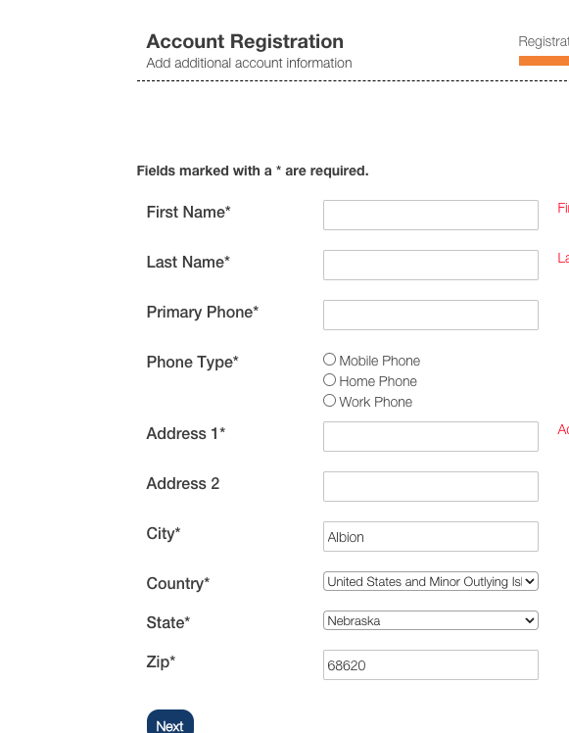
During registration if it asks for a family key code, please finish as much as you can on the account and then email jclassen@boonecentral.esu7.org
Please include the following in the email:
- Your name
- Your email used to register
- Your students names
The system will allow you to keep all of the settings until the key code is entered.

Once the keycode is entered the remaining windows will show.
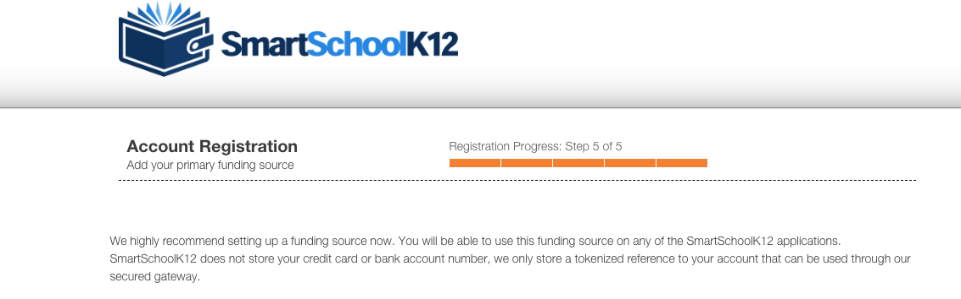
- Enter card information for a onetime payment.
- SAVE
- You will see your payment reflected regardless of payment method on your lunch dashboard.
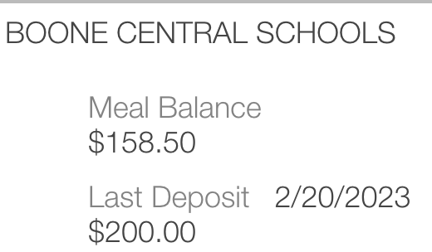

A few features that may interest you:
- Editing meal, vending, and milk permissions
In your Powerschool Sign In, click on
This will open a window that shows permissions for your student… including vending settings. Students in the elementary do not have access to the vending machine, middle school and high school students have access through these permissions.

In the interest of communication and student responsibility these permissions can be edited by through the parent portal here.
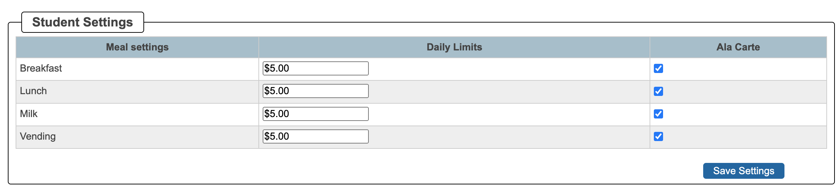

- Reviewing student transactions
On the powerschool dashboard you can review the transactions. This feature is also available through the wordware dashboard under
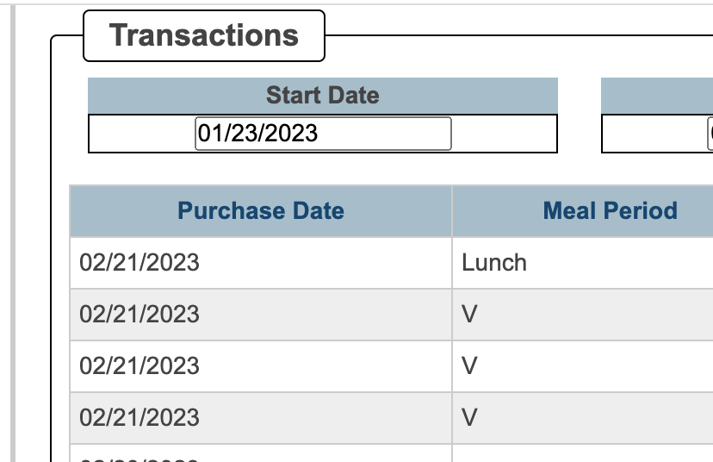
Please use this transaction information to stay informed on student purchases.
- Family member access
  - Click on the fork and go to family accounts
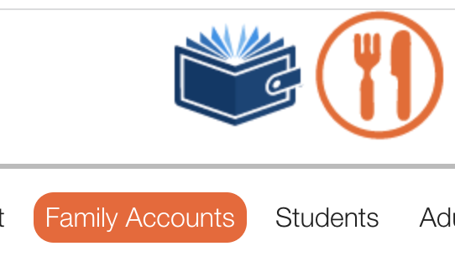
  - Enter the email of the person needing access
  - NOTE: this will give them access to the entire lunch account. If they only want to give a donation they can make an online payment or send a check/cash to the school.

If you have portal questions please contact Mrs. Classen at jclassen@boonecentral.esu7.org

